**JSS ACADEMY OF TECHNICAL EDUCATION**

**BANGALORE**



Internship Report on

HOUSE RENTAL WEBSITE

USING FULL STACK WEB DEVELOPMENT

BY

VARSHITA B M (1JS20CS180)

YASHASWINI S(1JS20CS189)

**FULL STACK WEB DEVELOPMENT INTERNSHIP**

**AT**

**PRINSTON SMART ENGINEERS**

**ABSTRACT**

Web development is the work involved in developing a web site for the internet (World Wide Web) or an intranet (a private network) web development can range from developing a simple single static page of plain text to complex web-based internet services. A more comprehensive list of tasks to which web development commonly refers, may include web design, web content development, client-side/server-side scripting, webserver and network configuration and ecommerce development. Web based house rental system is a toolkit which act as a interface between the user and admin. It helps the user to easily view house with the facilities of their choices and decide between options. It also makes the users work easier and comparatively faster than the traditional method of searching a house for rent. Also this piece of software, is easy to maintain and further enhancements can be added without any hassles.

**TABLE OF CONTENTS**

**SL NO. CHAPTERS PAGE NO.**

**1. INTRODUCTION……………………………………………………3**

1.1 HTML

1.2 CSS

1.3 JAVASCRIPT

1.4 BOOTSTRAP

1.5 XAMPP

1.6 MYSQL

1.7 PHP

**2. LITERATURE SURVEY……………………………………………7**

2.1 AIM OF THE PROJECT

2.2 PURPOSE OF THE PROJECT

2.3 BENEFITS OF THE

2.4 ABOUT THE PROJECT

**3. REQUIREMENT SPECIFICATION……………………………….9**

3.1 HARDWARE REQUIREMENTS

3.2 SOFTWARE REQUIREMENTS

**4. SOFTWARE DESIGN……………………………………………….10**

4.1 FRONT END

4.1.1 FUNCTIONALITIES

4.2 CONNECTION

4.3 BACK-END TASKS

4.4 PHP MYSQL CONNECTION

**5. IMPLEMENTATION……………………………………………….. 12**

**6. SNAPSHOTS………………………………………………………… 42**

**7. REFERENCES……………………………………………………………45**

**INTRODUCTION**

Web development is the work involved in developing a Web site for the Internet (World Wide Web) or an intranet (a private network). Web development can range from developing a simple single static page of plain text to complex Web-based Internet applications (Web apps), electronic businesses, and social network services. A more comprehensive list of tasks to which Web development commonly refers, may include Web design, Web content development, client-side/server-side scripting, Web server and network security configuration, and e-commerce development.

Among Web professionals, "Web development" usually refers to the main non-design aspects of building Web sites: writing markup and coding. Web development may use content management systems (CMS) to make content changes easier and available basic technical skills. For larger organizations and businesses, Web development teams can consist of hundreds of people (Web developers) and follow standard methods like Agile methodologies while developing Web sites. Smaller organizations may only require a single permanent or contracting developer, or secondary assignment to related job positions such as a graphic designer or information systems technician.

Web development may be a collaborative effort between departments rather than the domain of a designated department. There are three kinds of Web developer specialization: front-end developer, back-end developer, and full-stack developer. Front-end developers are responsible for behaviour and visuals that run in the user browser, while back-end developers deal with the servers. Full-stack developer must have knowledge about both front-end and back-end entities.

Since the commercialization of the Web, Web development has been a growing industry. The growth of this industry is being driven by businesses wishing to use their Web site to advertise and sell products and services to customers. There are many opensource tools for Web development such as Berkeley DB, Glass Fish, LAMP (Linux, Apache, MySQL, PHP) stack and Perl/Plack. This has kept the cost of learning Web development to a minimum. An ever-growing set of tools and technologies have helped developers build more dynamic and interactive Web sites.

Further we have given explanation of each resource used for the project that includes HTML, CSS, JavaScript, Bootstrap in front-end. While we use resources like PHP, MySQL for database creation and execution that is for back-end.

**FRONT-END TECHNOLOGIES**

**1.1 HTML**

Hypertext Markup Language (HTML) is the standard markup language for documents designed to be displayed in a web browser. It can be assisted by technologies such as Cascading Style Sheets (CSS) and scripting languages such as JavaScript.

Web browsers receive HTML documents from a web server or from local storage and render the documents into multimedia web pages.

HTML describes the structure of a web page semantically and originally included cues for the appearance of the document. HTML elements are the building blocks of HTML pages. With HTML constructs, images and other objects such as interactive forms may be embedded into the rendered page. HTML provides a means to create structured documents by denoting structural semantics for text such as headings, paragraphs, lists, links, quotes and other items. HTML elements are delineated by tags, written using angle brackets. Tags such as <img/> and <input/> directly introduce content into the page. Other tags such as <p> surround and provide information about document text and may include other tags as sub-elements. Browsers do not display the HTML tags, but use them to interpret the content of the page.HTML can embed programs written in a scripting language such as JavaScript, which affects the behaviour and content of web pages. Inclusion of CSS defines the look and layout of content.

**1.2 CSS Cascading Style Sheets (CSS)**

CSS is a style sheet language used for describing the presentation of a document written in a markup language such as HTML. CSS is a cornerstone technology of the World Wide Web, alongside HTML and JavaScript. CSS is designed to enable the separation of presentation and content, including layout, colours, and fonts.

This separation can improve content accessibility, provide more flexibility and control in the specification of presentation characteristics, enable multiple web pages to share formatting by specifying the relevant CSS in a separate .CSS file which reduces complexity and repetition in the structural content as well as enabling the .CSS file to be cached to improve the page load speed between the pages that share the file and its formatting. Separation of formatting and content also makes it feasible to present the same markup page in different styles for different rendering methods, such as on-screen, in print, by voice (via speechbased browser or screen reader), and on Braille-based tactile devices. CSS also has rules for alternate formatting if the content is accessed on a mobile device. The name cascading comes from the specified priority scheme to determine which style rule applies if more than one rule matches a particular element. This cascading priority scheme is predictable.

The CSS specifications are maintained by the World Wide Web Consortium (W3C). Internet media type (MIME type) text/CSS is registered for use with CSS by RFC 2318 (March 1998). The W3C operates a free CSS validation service for CSS documents. In addition to HTML, other markup languages support the use of CSS including XHTML, plain XML, SVG, and XUL.

**1.3 JAVASCRIPT**

JavaScript often abbreviated as JS, is a [programming language](https://en.wikipedia.org/wiki/Programming_language) that is one of the core technologies of the [World Wide Web](https://en.wikipedia.org/wiki/World_Wide_Web), alongside [HTML](https://en.wikipedia.org/wiki/HTML) and [CSS](https://en.wikipedia.org/wiki/CSS). It is used on the [client](https://en.wikipedia.org/wiki/Client_(computing)) side for [webpage](https://en.wikipedia.org/wiki/Web_page) behaviour, often incorporating third-party [libraries](https://en.wikipedia.org/wiki/Library_(computing)). All major [web browsers](https://en.wikipedia.org/wiki/Web_browser) have a dedicated [JavaScript engine](https://en.wikipedia.org/wiki/JavaScript_engine) to execute the [code](https://en.wikipedia.org/wiki/Source_code) on [users](https://en.wikipedia.org/wiki/User_(computing))' devices.

JavaScript is a [high-level](https://en.wikipedia.org/wiki/High-level_programming_language), often [just-in-time compiled](https://en.wikipedia.org/wiki/Just-in-time_compilation) language that conforms to the [ECMAScript](https://en.wikipedia.org/wiki/ECMAScript) standard.[[10]](https://en.wikipedia.org/wiki/JavaScript#cite_note-tc39-10) It has [dynamic typing](https://en.wikipedia.org/wiki/Dynamic_typing), [prototype-based](https://en.wikipedia.org/wiki/Prototype-based_programming) [object-orientation](https://en.wikipedia.org/wiki/Object-oriented_programming), and [first-class functions](https://en.wikipedia.org/wiki/First-class_function). It is [multi-paradigm](https://en.wikipedia.org/wiki/Programming_paradigm), supporting [event-driven](https://en.wikipedia.org/wiki/Event-driven_programming), [functional](https://en.wikipedia.org/wiki/Functional_programming), and [imperative](https://en.wikipedia.org/wiki/Imperative_programming) [programming styles](https://en.wikipedia.org/wiki/Programming_paradigm). It has [application programming interfaces](https://en.wikipedia.org/wiki/Application_programming_interface) (APIs) for working with text, dates, [regular expressions](https://en.wikipedia.org/wiki/Regular_expression), standard [data structures](https://en.wikipedia.org/wiki/Data_structure), and the [Document Object Model](https://en.wikipedia.org/wiki/Document_Object_Model) (DOM).

**1.4 BOOTSTRAP**

Bootstrap is a free and open-source CSS framework directed at responsive, mobile-first front-end web development. It contains CSS- and (optionally) JavaScript-based design templates for typography, forms, buttons, navigation, and other interface components.

It is an HTML, CSS and JS Library that focuses on simplifying the development of informative web pages. The primary purpose of adding it to a web project is to apply Bootstrap's choices of colour, size, font and layout to that project. Once added to a project, Bootstrap provides basic style definitions for all [HTML elements](https://en.wikipedia.org/wiki/HTML_element). The result is a uniform appearance for prose, tables and form elements across [web browsers](https://en.wikipedia.org/wiki/Web_browser). In addition, developers can take advantage of CSS classes defined in Bootstrap to further customize the appearance of their contents. For example, Bootstrap has provisioned for light- and dark-coloured tables, page headings, more prominent [pull quotes](https://en.wikipedia.org/wiki/Pull_quote), and text with a highlight.

Bootstrap also comes with several JavaScript components which do not require other libraries like [jQuery](https://en.wikipedia.org/wiki/JQuery). They provide additional user interface elements such as [dialog boxes](https://en.wikipedia.org/wiki/Dialog_box), [tooltips](https://en.wikipedia.org/wiki/Tooltip), progress bars, navigation drop-downs, and carousels. Each Bootstrap component consists of an HTML structure, CSS declarations, and in some cases accompanying JavaScript code. They also extend the functionality of some existing interface elements, including for example an auto-complete function for input fields.

The most prominent components of Bootstrap are its layout components, as they affect an entire web page. The basic layout component is called "Container", as every other element in the page is placed in it. Developers can choose between a fixed-width container and a fluid-width container.

**BACK-END TECNOLOGIES**

* 1. **XAMPP**

XAMPP is a free and open-source cross-platform web server solution stack package developed by Apache Friends, consisting mainly of the Apache HTTP Server, MariaDB database, and interpreters for scripts written in the PHP and Perl programming languages. Since most actual web server deployments use the same components as XAMPP, it makes transitioning from a local test server to a live server possible. XAMPP ease of deployment means a WAMP or LAMP stack can be installed quickly and simply on an operating system by a developer, with the advantage that common add-in applications such as WordPress and Joomla can also be installed with similar ease using Bitnami.

**1.6 MYSQL**

MySQL is multithreaded, multi user SQL database management System (DBMS). The basic program runs as server providing multiuser access to a number of databases. The project’s source code is available under terms of the GNU General Public License, as well as under a variety of property arguments. MySQL is a database. The data in a MySQL is stored in a Database-objects called tables. A table is a collection of related data entries and it consists of columns and rows. The databases are useful when storing information categorically. MySQL is a central components of the LAMP open-source web application software stack (and other “AMP” stacks). LAMP is an acronym for Linux, Apache, MySQL, Perl/PHP/ Python. Application that uses the MySQL database include TYP03, MODx, Joomla, WordPress, PHPBB, MyBB and Drupal. MySQL is also used in many high-profile, large-scale web sites, including Google.

* 1. **PHP**

PHP code may be executed with a command line interface (CLI), embedded into HTML code, or used in combination with various web template systems, web content management systems, and web frameworks. PHP code is usually processed by a PHP interpreter implemented as a module in a web server or as a Common Gateway Interface (CGI) executable. The web server outputs the results of the interpreted and executed PHP code, which may be any type of data, such as generated HTML code or binary image data. PHP can be used for many programming tasks outside of the web context, such as standalone graphical applications and robotic drone control. The standard PHP interpreter, powered by the Zend Engine, is free software released under the PHP License. PHP has been widely ported and can be deployed on most web servers on almost every operating system and platform, free of charge. The PHP language evolved without a written formal specification or standard until 2014, with the original implementation acting as the de facto standard which other implementations aimed to follow. Since 2014, work has gone on to create a formal PHP specification.

**LITERATURE SURVEY**

**2.1 AIM OF THE PROJECT:**

To develop a house rental website where user can look into the houses for rent and he contacts the managers for the rental procedure.

Here we have mainly focused on admin panel where admin can change the settings of the page and he can look into the user queries sent by the user. He can also update and retrieve the staff information dynamically.

**2.2 Purpose of the project:**

The Main purpose of this project is to design, build and implement a house rental website with anytime and anywhere access availability. All the user queries will be stored in user queries page which can retrieved and viewed by admin.

This project is mainly designed to provide an easy-to-use interface for user and admin to interact with each other during the course of rental procedure. Thus helping out the users to select best possible house of their choice with facilities they want .

**2.3 The benefits of the Project:**

✓ Simplicity: The project is easy and simple to use.

✓ Usability: It is easy to use.

✓ Flexibility: It is very flexible since it is easy to add new features to it.

**2.4 About the project**

• The proposed project is a House rental system for customers who are in search of perfect place to live.

• Its role is to assist customers to rent a house of their choice. It is a simple user interface which has two types of users: admin and students. The rental system can be used to keep track of different houses available. Thus, with the help of this system the customers can easily rent a well-suited house.

**REQUIREMENT SPECIFICATION**

The system requirement and specification of our project is as follows:

* **Hardware Requirements** 
  + Processor: i5 Core Processor
  + Monitor: 1024 * 768 Resolution Colour
  + Keyboard: QWERTY RAM: 1 GB
  + Motherboard: 845c Intel Motherboard
  + Backup Media: Floppy/pen drive/Hard disk.
  + Hard disk: 2 TB HDD
  + I/O Device: Standard input and output devices.
* **Software Requirements** 
  + MySQL Libraries
  + Xampp software: Apache Server
  + Operating system: Windows 10

**SOFTWARE DESIGN**

**4.1 FRONT END**

1. Create Admin login page.

2.Create the landing page in both Admin and user.

3. Create all the necessary pages for each link and the functionalities.

4. Style all the Web pages.

**4.1.1 Functionalities**

We have implemented the following functionalities in the project: -

• ADMIN Side Functionalities:

1.Admin must be able to log in to his panel.

2. Admin must be able to add a new staff into the database.

3. Delete staff records.

4. change the settings of website.

5. check the user queries.

• USER Side Functionalities:

1. He can check staff details.

2. Enters his queries in contact us panel.

**4.2 CONNECTION**

1. Implement the functionalities for each of the web page.

2. Use the appropriate Query for the functionalities.

3. Follow the same procedure:

- Create a SQL Template.

- Prepare the statement.

- Bind the parameters if required.

- Execute the statement.

* 1. **BACK-END TASKS**

1. Create 5 tables.

2. After the required Tables and add the key Functionalities.

3. Insert the values into the tables.

4. Create views as per requirement.

**STAFF DETAILS ADMIN-CREDENTIALS**

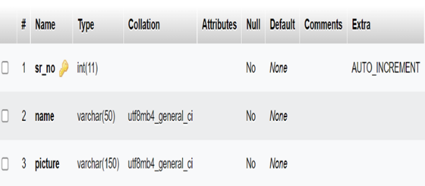 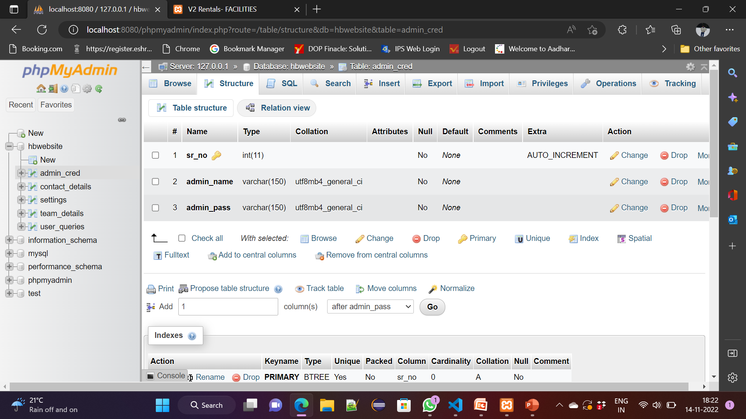

**SETTINGS**

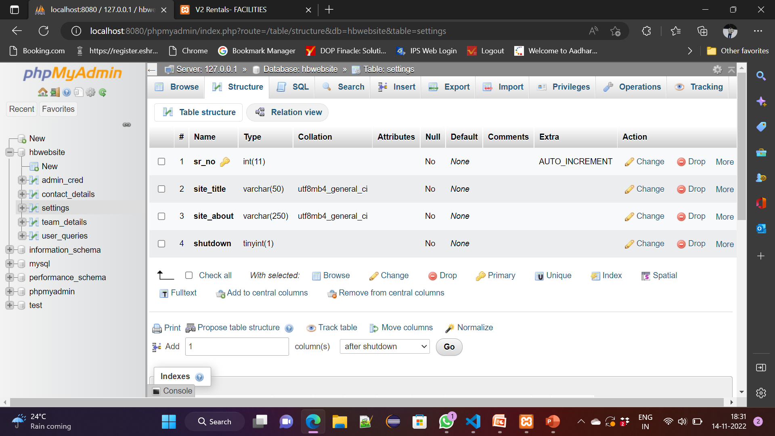

**USER QUERIES CONTACT US**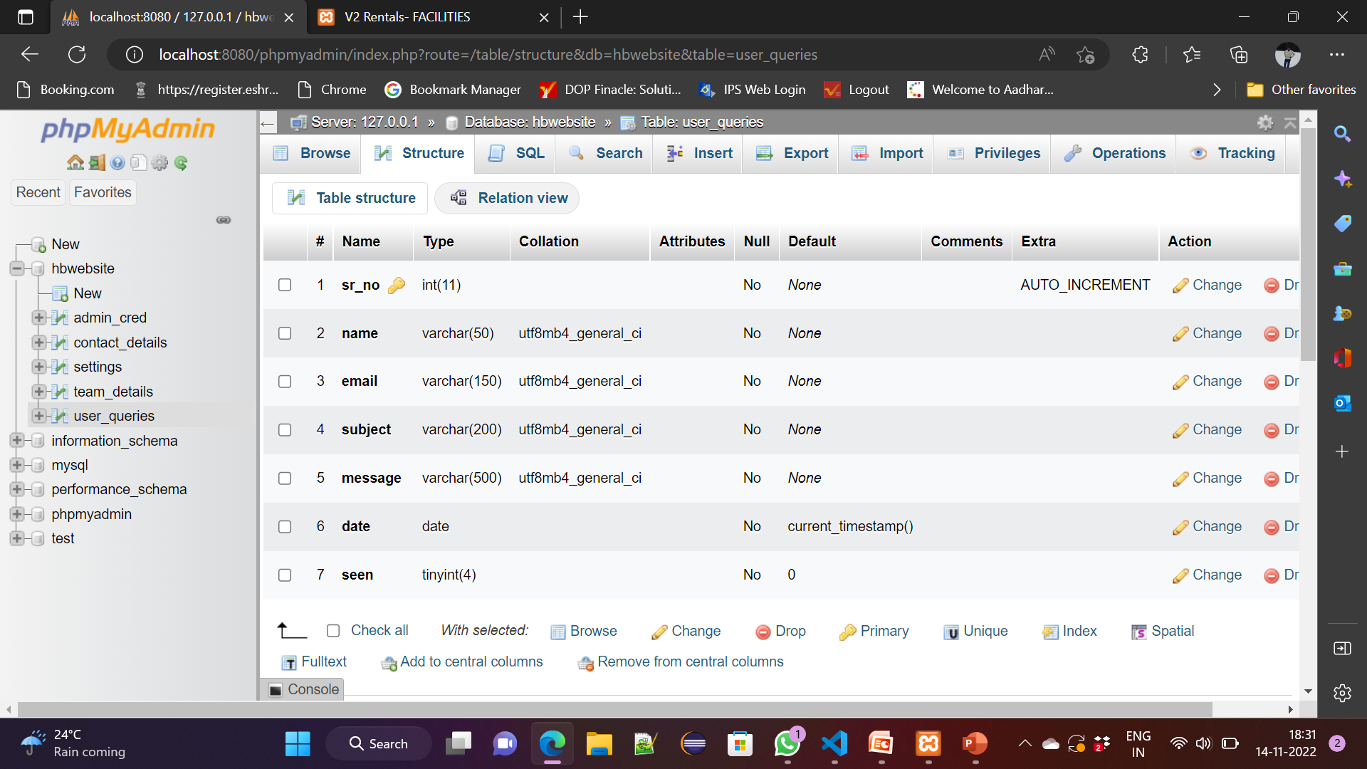 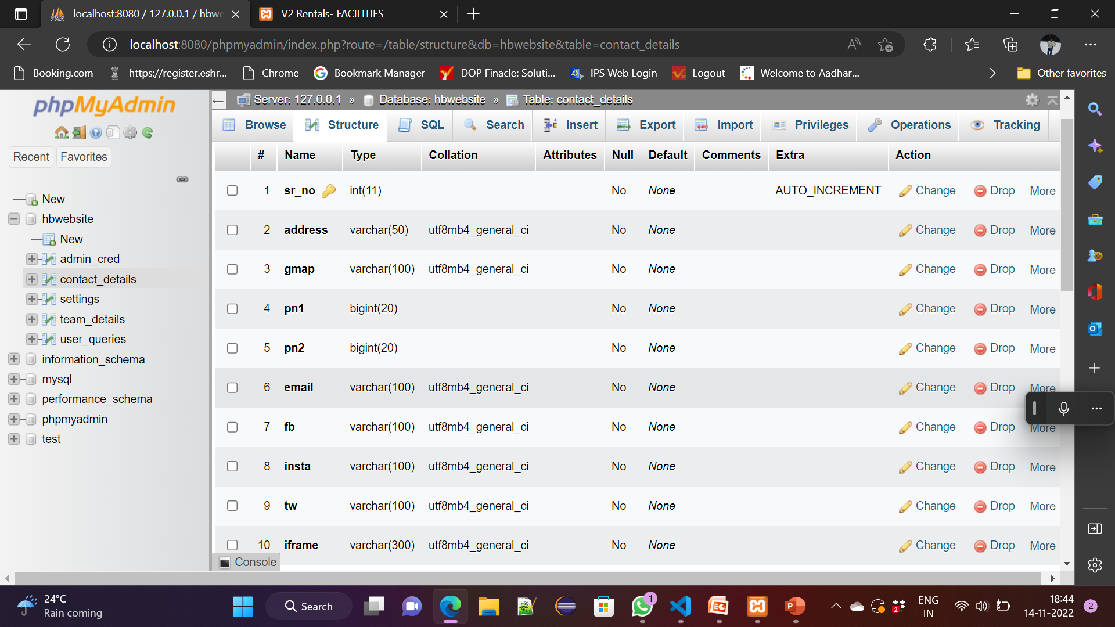

4.4 **PHP MYSQL CONNECTION**

* Depending on the version of PHP, there are either two or three PHP APIs for accessing the MySQL database.
* PHP 5 users can choose between the deprecated MySQL extension, mysqli, or PDO.
* PHP 7 removes the MySQL extension, leaving only mysqli and PDO.
* Mysqli – MySQL improved.

**IMPLEMENTATION**

**5.1 CREATION OF TABLES**

**1. Admin**

CREATE TABLE `admin_credential` (`sr_no` int (10) NOT NULL, `admin_name` varchar (150), `admin_pass` varchar (150));

**2. Staff_details**

CREATE TABLE `staff_details` (`sr_no` int (10) NOT NULL, `name` varchar (50), `picture` varchar (150));

**3. Settings**

CREATE TABLE `settings` (`sr_no` int (10) NOT NULL, `site_title` varchar (50), `site_about` varchar (150));

**4. User_queries**

CREATE TABLE `user_queries` (`sr_no` int (10) NOT NULL, `name` varchar (50), `email` varchar (150), `subject` varchar (200), `message` varchar (500), `date` date, `seen` tinyint (4));

**5.Contact_us**

CREATE TABLE `contact_us` (`sr_no` int (10) NOT NULL, `address` varchar (50), `gmap` varchar (100), `pn1` bigint (20), `pn2` bigint (20), `email` varchar (100), `fb` varchar (100), `tw` varchar (100), `insta` varchar (100), `iframe` varchar (300));

`

**5.2 CODE FOR IMPORTANT MODULES**

**Index.php of user website**

<!DOCTYPE html>

<html lang="en">

<head>

<meta charset="UTF-8">

<meta http-equiv="X-UA-compatible" content="IE=edge">

<meta name="viewport" content="width=device-width, initial-scale=1.0">

<title>V2 Rentals</title>

<link rel="stylesheet" href="https://cdn.jsdelivr.net/npm/swiper@8/swiper-bundle.min.css" />

<?php require('inc/links.php'); ?>

<style>

.availability-form{

margin-top: -50px;

z-index: 2;

position: relative;

}

@media screen and (max-width: 575px){

.availability-form{

margin-top: 25px;

padding: 0 35px

}

}

</style>

</head>

<body class="bg-light">

<?php require('inc/header.php'); ?>

<!-- Carousal -->

<div class="container-fluid px-lg-4 mt-4">

<div class="swiper swiper-container">

<div class="swiper-wrapper">

<div class="swiper-slide">

<img src="images/carousel/1.png" class="w-100 d-block" />

</div>

<div class="swiper-slide">

<img src="images/carousel/2.png" class="w-100 d-block" />

</div>

<div class="swiper-slide">

<img src="images/carousel/3.png" class="w-100 d-block" />

</div>

<div class="swiper-slide">

<img src="images/carousel/4.png" class="w-100 d-block" />

</div>

<div class="swiper-slide">

<img src="images/carousel/5.png" class="w-100 d-block"/>

</div>

<div class="swiper-slide">

<img src="images/carousel/6.png" class="w-100 d-block" />

</div>

<div class="swiper-slide">

<img src="images/carousel/7.png" class="w-100 d-block" />

</div>

</div>

</div>

</div>

<!-- our rooms -->

<h2 class="mt-5 pt-4 mb-4 text-center fw-bold h-font">OUR HOUSES</h2>

<div class="container">

<div class="row">

<div class="col-lg-4 col-md-6 my-3">

<div class="card border-0" style="max-width: 350px; margin:auto;">

<img src="images/rbhouse/1.jpg" class="card-img-top">

<div class="card-body">

<h5>House name</h5>

<h6 class="mb-4">₹35000 per month</h6>

<div class="features mb-4">

<h6 class="mb-1">Features</h6>

<span class="badge rounded-pill bg-light text-dark text-wrap lh-base">

4 bedrooms

</span>

<span class="badge rounded-pill bg-light text-dark text-wrap lh-base">

3 bathrooms

</span>

<span class="badge rounded-pill bg-light text-dark text-wrap lh-base">

2 balcony

</span>

<span class="badge rounded-pill bg-light text-dark text-wrap lh-base">

Semifurnished

</span>

</div>

<div class="facilities mb-4">

<h6 class="mb-1">Facilities</h6>

<span class="badge rounded-pill bg-light text-dark text-wrap lh-base">

24×7 water and current supply

</span>

<span class="badge rounded-pill bg-light text-dark text-wrap lh-base">

Gym

</span>

<span class="badge rounded-pill bg-light text-dark text-wrap lh-base">

Swimming pool

</span>

</span>

<span class="badge rounded-pill bg-light text-dark text-wrap lh-base">

Large Parking Area

</span>

<span class="badge rounded-pill bg-light text-dark text-wrap lh-base">

Kids Area

</span>

</div>

<div class="rating mb-4">

<h6 class="mb-1">Rating</h6>

<span class="badge rounded-pill bg-light">

<i class="bi bi-star-fill text-warning"></i>

<i class="bi bi-star-fill text-warning"></i>

<i class="bi bi-star-fill text-warning"></i>

<i class="bi bi-star-fill text-warning"></i>

</span>

</div>

<div class="d-flex justify-content-evenly mb-2">

<a href="popmessage.php" class="btn btn-sm text-white custom-bg shadow-none">More details</a>

</div>

</div>

</div>

</div>

<div class="col-lg-4 col-md-6 my-3">

<div class="card border-0" style="max-width: 350px; margin:auto;">

<img src="images/rbhouse/2.jpg" class="card-img-top">

<div class="card-body">

<h5>House name</h5>

<h6 class="mb-4">₹25000 per month</h6>

<div class="features mb-4">

<h6 class="mb-1">Features</h6>

<span class="badge rounded-pill bg-light text-dark text-wrap lh-base">

3 bedrooms

</span>

<span class="badge rounded-pill bg-light text-dark text-wrap lh-base">

2 bathrooms

</span>

<span class="badge rounded-pill bg-light text-dark text-wrap lh-base">

1 balcony

</span>

</div>

<div class="facilities mb-4">

<h6 class="mb-1">Facilities</h6>

<span class="badge rounded-pill bg-light text-dark text-wrap lh-base">

24×7 water and current supply

</span>

<span class="badge rounded-pill bg-light text-dark text-wrap lh-base">

Swimming pool

</span>

</span>

<span class="badge rounded-pill bg-light text-dark text-wrap lh-base">

Large Parking Area

</span>

</div>

<div class="rating mb-4">

<h6 class="mb-1">Rating</h6>

<span class="badge rounded-pill bg-light">

<i class="bi bi-star-fill text-warning"></i>

<i class="bi bi-star-fill text-warning"></i>

<i class="bi bi-star-fill text-warning"></i>

<i class="bi bi-star-fill text-warning"></i>

</span>

</div>

<div class="d-flex justify-content-evenly mb-2">

<a href="popmessage.php" class="btn btn-sm text-white custom-bg shadow-none">More details</a>

</div>

</div>

</div>

</div>

<div class="col-lg-4 col-md-6 my-3">

<div class="card border-0" style="max-width: 350px; margin:auto;">

<img src="images/rbhouse/3.jpg" class="card-img-top">

<div class="card-body">

<h5>House name</h5>

<h6 class="mb-4">₹15000 per month</h6>

<div class="features mb-4">

<h6 class="mb-1">Features</h6>

<span class="badge rounded-pill bg-light text-dark text-wrap lh-base">

2 bedrooms

</span>

<span class="badge rounded-pill bg-light text-dark text-wrap lh-base">

2 bathrooms

</span>

<span class="badge rounded-pill bg-light text-dark text-wrap lh-base">

1 balcony

</span>

<span class="badge rounded-pill bg-light text-dark text-wrap lh-base">

Semifurnished

</span>

</div>

<div class="facilities mb-4">

<h6 class="mb-1">Facilities</h6>

<span class="badge rounded-pill bg-light text-dark text-wrap lh-base">

24×7 water and current supply

</span>

<span class="badge rounded-pill bg-light text-dark text-wrap lh-base">

Gym

</span>

</span>

<span class="badge rounded-pill bg-light text-dark text-wrap lh-base">

Large Parking Area

</span>

</div>

<div class="rating mb-4">

<h6 class="mb-1">Rating</h6>

<span class="badge rounded-pill bg-light">

<i class="bi bi-star-fill text-warning"></i>

<i class="bi bi-star-fill text-warning"></i>

<i class="bi bi-star-fill text-warning"></i>

</span>

</div>

<div class="d-flex justify-content-evenly mb-2">

<a href="popmessage.php" class="btn btn-sm text-white custom-bg shadow-none">More details</a>

</div>

</div>

</div>

</div>

<div class="col-lg-12 text-center mt-5">

<a href="house.php" class="btn btn-sm btn-outline-dark rounded-0 fw-bold shadow-none"> More Houses>>></a>

</div>

</div>

</div>

<!-- our facilities -->

<h2 class="mt-5 pt-4 mb-4 text-center fw-bold h-font">OUR FACILITIES</h2>

<div class="container">

<div class="row justify-content-evenly px-lg-0 px-md-0 px-5">

<div class="col-lg-2 col-md-2 text-center bg-white rounded shadow py-4 my-3">

<img src="images/features/gym.svg" width="80px">

<h5 class="mt-3">Gym</h5>

</div>

<div class="col-lg-2 col-md-2 text-center bg-white rounded shadow py-4 my-3">

<img src="images/features/parking.svg" width="80px">

<h5 class="mt-3">parking availability</h5>

</div>

<div class="col-lg-2 col-md-2 text-center bg-white rounded shadow py-4 my-3">

<img src="images/features/swim.svg" width="80px">

<h5 class="mt-3">Swimming area</h5>

</div>

<div class="col-lg-2 col-md-2 text-center bg-white rounded shadow py-4 my-3">

<img src="images/features/cctv.svg" width="80px">

<h5 class="mt-3">24/7 Survalliance</h5>

</div>

<div class="col-lg-2 col-md-2 text-center bg-white rounded shadow py-4 my-3">

<img src="images/features/garden.svg" width="80px">

<h5 class="mt-3">Garden area</h5>

</div>

<div class="col-lg-12 text-center mt-5">

<a href="facilities.php" class="btn btn-sm btn-outline-dark rounded-0 fw-bold shadow-none"> More Facilities>>></a>

</div>

</div>

</div>

<!-- Testimonials -->

<h2 class="mt-5 pt-4 mb-4 text-center fw-bold h-font">TESTIMONIALS</h2>

<div class="container mt-5">

<div class="swiper swiper-testimonials">

<div class="swiper-wrapper mb-5">

<div class="swiper-slide bg-white p-4">

<div class="profile d-flex align-items-center mb-3 ">

<img src=" images/features/star.svg" width="30px">

<h6 class="m-0 ms-2">Random user1</h6>

</div>

<p>

We've been with V2 rentals for 11 years. We can always count on receiving strong leads from them and appreciate their top-notch customer service.

</p>

<div class="rating">

<i class="bi bi-star-fill text-warning"></i>

<i class="bi bi-star-fill text-warning"></i>

<i class="bi bi-star-fill text-warning"></i>

<i class="bi bi-star-fill text-warning"></i>

</div>

</div>

<div class="swiper-slide bg-white p-4">

<div class="profile d-flex align-items-center mb-3 ">

<img src=" images/features/star.svg" width="30px">

<h6 class="m-0 ms-2">Random user1</h6>

</div>

<p>

Such an amazing website.I am very much satisfied with the service provided by them.

</p>

<div class="rating">

<i class="bi bi-star-fill text-warning"></i>

<i class="bi bi-star-fill text-warning"></i>

<i class="bi bi-star-fill text-warning"></i>

<i class="bi bi-star-fill text-warning"></i>

</div>

</div>

<div class="swiper-slide bg-white p-4">

<div class="profile d-flex align-items-center mb-3 ">

<img src=" images/features/star.svg" width="30px">

<h6 class="m-0 ms-2">Random user1</h6>

</div>

<p>

We've been with V2 rentals for 11 years. We can always count on receiving strong leads from them.

</p>

<div class="rating">

<i class="bi bi-star-fill text-warning"></i>

<i class="bi bi-star-fill text-warning"></i>

<i class="bi bi-star-fill text-warning"></i>

<i class="bi bi-star-fill text-warning"></i>

</div>

</div>

</div>

<div class="swiper-pagination"></div>

</div>

<!-- <div class="col-lg-12 text-center mt-5">

<a href="#" class="btn btn-sm btn-outline-dark rounded-0 fw-bold shadow-none"> Know more>>></a>

</div> -->

</div>

<!-- Reach us -->

<h2 class="mt-5 pt-4 mb-4 text-center fw-bold h-font">REACH US</h2>

<div class="container">

<div class="row">

<div class="col-lg-8 col-md-8p-4 mb-lg-0 mb-3 bg-white rounded">

<iframe class="w-100 rounded" height="320px" src="//www.google.com/maps/embed?pb=!1m14!1m8!1m3!1d995399.3982503342!2d77.63094!3d12.953997!3m2!1i1024!2i768!4f13.1!3m3!1m2!1s0x3bae1670c9b44e6d%3A0xf8dfc3e8517e4fe0!2sBengaluru%2C%20Karnataka!5e0!3m2!1sen!2sin!4v1668316270134!5m2!1sen!2sin" loading="lazy" ></iframe>

</div>

<div class="col-lg-4 col-md-4">

<div class="bg-white p-4 rounded mb-4">

<h5>Call us</h5>

<a href="tel: +<?php echo $contact_r['pn1']?>" class="d-inline-block mb-2 text-decoration-none text-dark">

<i class="bi bi-telephone-fill"></i> +<?php echo $contact_r['pn1']?>

</a>

<br>

<?php

if($contact_r['pn2']!=''){

echo<<<data

<a href="tel: +$contact_r[pn2]" class="d-inline-block text-decoration-none text-dark">

<i class="bi bi-telephone-fill"></i> +$contact_r[pn2]

</a>

data;

}

?>

</div>

<div class="bg-white p-4 rounded mb-4">

<h5>Follow us</h5>

<a href="<?php echo $contact_r['tw']?>"class="d-inline-block mb-3">

<span class="badge bg-light text-dark fs-6 p-2">

<i class="bi bi-twitter me-1"></i> Twitter

</span>

</a>

<br>

<a href="<?php echo $contact_r['fb']?>" class="d-inline-block mb-3">

<span class="badge bg-light text-dark fs-6 p-2">

<i class="bi bi-facebook me-1"></i> Facebook

</span>

</a>

<br>

<a href="<?php echo $contact_r['insta']?>" class="d-inline-block ">

<span class="badge bg-light text-dark fs-6 p-2">

<i class="bi bi-instagram me-1"></i> Instagram

</span>

</a>

</div>

</div>

</div>

</div>

<?php require('inc/footer.php'); ?>

<script src="https://cdn.jsdelivr.net/npm/swiper@8/swiper-bundle.min.js"></script>

<script>

var swiper = new Swiper(".swiper-container", {

spaceBetween: 30,

effect: "fade",

loop:true,

autoplay:{

delay:3500,

disableOnInteraction: false,

}

});

var swiper = new Swiper(".swiper-testimonials", {

effect: "coverflow",

grabCursor: true,

centeredSlides: true,

slidesPerView: "auto",

slidesPerView: "3",

loop: true,

coverflowEffect: {

rotate: 50,

stretch: 0,

depth: 100,

modifier: 1,

slideShadows: false,

},

pagination: {

el: ".swiper-pagination",

},

breakpoints:{

320:{

slidesPerView: 1,

},

640:{

slidesPerView: 1,

},

768:{

slidesPerView: 2,

},

1024:{

slidesPerView: 3,

},

}

});

</script>

</body>

</html>

**Header.php of user website**

?php

require('admin/inc/db_config.php');

require('admin/inc/essentials.php');

$contact_q="SELECT * FROM `contact_details` WHERE `sr_no`=?";

$values = [1];

$contact_r = mysqli_fetch_assoc(select($contact_q,$values,'i'));

?>

<nav id="nav-bar" class="navbar navbar-expand-lg navbar-light bg-light">

<div class="container-fluid">

<a class="navbar-brand me-5 fw-bold fs-3 h-font" href="index.php">V2 Rentals</a>

<button class="navbar-toggler shadow-none" type="button" data-bs-toggle="collapse" data-bs-target="#navbarSupportedContent" aria-controls="navbarSupportedContent" aria-expanded="false" aria-label="Toggle navigation">

<span class="navbar-toggler-icon"></span>

</button>

<div class="collapse navbar-collapse" id="navbarSupportedContent">

<ul class="navbar-nav me-auto mb-2 mb-lg-0">

<li class="nav-item">

<a class="nav-link me-2" href="index.php">Home</a>

</li>

<li class="nav-item">

<a class="nav-link me-2" href="house.php">House</a>

</li>

<li class="nav-item">

<a class="nav-link me-2" href="facilities.php">Facilities</a>

</li>

<li class="nav-item">

<a class="nav-link me-2" href="about.php">About us</a>

</li>

<li class="nav-item">

<a class="nav-link " href="contact.php">Contact us</a>

</li>

</ul>

<div class="d-flex">

</div>

</div>

</div>

</nav>

**Footer.php of user website**

<div class="container-fluid bg-white mt-5">

<div class="row">

<div class="col-lg-4 p-4">

<h3 class="h-font fw-bold fs-3 mb-2"> V2 RENTALS</h3>

<p>

Completed applications and reports are generated instantly and immediately shared with landlords, drastically reducing cycle times and empowering renters to receive a decision in hours instead of days

</p>

</div>

<div class="col-lg-4 p-4">

<h5 class="mb-3">LINKS</h5>

<a href="index.php" class="d-inline-block md-2 text-dark text-decoration-none">Home</a><br>

<a href="house.php" class="d-inline-block md-2 text-dark text-decoration-none">House</a><br>

<a href="facilities.php" class="d-inline-block md-2 text-dark text-decoration-none">Facilities</a><br>

<a href="contact.php" class="d-inline-block md-2 text-dark text-decoration-none">Contact us</a><br>

<a href="about.php" class="d-inline-block md-2 text-dark text-decoration-none">About us</a>

</div>

<div class="col-lg-4 p-4">

<h5>Follow us</h5>

<a href="<?php echo $contact_r['tw']?>" class="d-inline-block mb-2 text-dark text-decoration-none">

<i class="bi bi-twitter me-1"></i> Twitter

</a><br>

<a href="<?php echo $contact_r['fb']?>" class="d-inline-block mb-2 text-dark text-decoration-none">

<i class="bi bi-facebook me-1"></i> Facebook

</a><br>

<a href="<?php echo $contact_r['insta']?>" class="d-inline-block text-dark text-decoration-none">

<i class="bi bi-instagram me-1"></i> Instagram

</a><br>

</div>

</div>

</div>

<script src="https://cdn.jsdelivr.net/npm/bootstrap@5.0.2/dist/js/bootstrap.bundle.min.js" integrity="sha384-MrcW6ZMFYlzcLA8Nl+NtUVF0sA7MsXsP1UyJoMp4YLEuNSfAP+JcXn/tWtIaxVXM" crossorigin="anonymous"></script>

<script>

function setActive()

{

let navbar = document.getElementById('nav-bar');

let a_tags = navbar.getElementsByTagName('a');

for(i=0; i<a_tags.length; i++)

{

}

}

</script>

**Common.css of user website**

:root{

--teal: #2ec1ac;

--teal_hover: #279e8c;

}

*{

font-family: 'Poppins', sans-serif;

}

.h-font{

font-family: 'Merienda', cursive;

}

input::-webkit-outer-spin-button,

input::-webkit-inner-spin-button {

-webkit-appearance: none;

margin: 0;

}

input[type=number] {

-moz-appearance: textfield;

}

.custom-bg{

background-color: var(--teal);

border: 1px solid var(--teal);

}

.custom-bg:hover{

background-color: var(--teal_hover);

border-color: var(--teal);

}

.h-line{

width:150px;

margin:0 auto;

height: 1.7px;

}

.custom-alert{

position: fixed;

top: 25px;

right: 25px;

}

**Index.php of admin page**

<?php

require('inc/essentials.php');

require('inc/db_config.php');

session_start();

if((isset($_SESSION['adminLogin']) && $_SESSION['adminLogin']==true)){

redirect('dashboard.php');

}

?>

<!DOCTYPE html>

<html lang="en">

<head>

<meta charset="UTF-8">

<meta http-equiv="X-UA-Compatible" content="IE=edge">

<meta name="viewport" content="width=device-width, initial-scale=1.0">

<title>Admin Login panel</title>

<?php require('inc/links.php'); ?>

<style>

div.login-form{

position:absolute;

top:50%;

left:50%;

transform:translate(-50%,-50%);

width:400px;

}

</style>

</head>

<body class="bg-light">

<div class="login-form text-center rounded bg-white shadow overflow-hidden">

<form method="POST">

<h4 class="bg-dark text-white py-3">ADMIN LOGIN PANEL</h4>

<div class="p-4">

<div class="mb-3">

<input name = "admin_name" required type="text" class="form-control shadow-none text-center" placeholder="Admin Name">

</div>

<div class="mb-4">

<input name="admin_pass" required type="password" class="form-control shadow-none text-center" placeholder="Password">

</div>

<button name="login" type="submit" class="btn text-white custom-bg shadow-none">

LOGIN

</button>

</div>

</form>

</div>

<?php

if(isset($_POST['login']))

{

$frm_data= filteration($_POST);

$query="SELECT * FROM `admin_cred` WHERE `admin_name`=? AND `admin_pass`=?";

$values=[$frm_data['admin_name'],$frm_data['admin_pass']];

$res = select($query,$values,"ss");

if($res->num_rows==1){

$row = mysqli_fetch_assoc($res);

$_SESSION['adminLogin']=true;

$_SESSION['adminId']=$row['sr_no'];

redirect('dashboard.php');

}

else{

alert('error','LOGIN FAILED - Invalid credentials!');

}

}

?>

<?php require('inc/scripts.php'); ?>

</body>

</html>

**Dashboard.php of admin page**

<?php

require('inc/essentials.php');

adminLogin();

session_regenerate_id(true);

?>

<!DOCTYPE html>

<html lang="en">

<head>

<meta charset="UTF-8">

<meta http-equiv="X-UA-Compatible" content="IE=edge">

<meta name="viewport" content="width=device-width, initial-scale=1.0">

<title>Admin Panel - Dashboard</title>

<?php require('inc/links.php'); ?>

</head>

<body class="bg-light">

<?php require('inc/header.php'); ?>

<div class="container-fluid " id="main-content">

<div class="row">

<div class="col-lg-10 ms-auto p-4 overflow-hidden">

<div class="my-5 px-4">

<h2 class="fw-bold h-font text-center">OUR FACILITIES</h2>

<div class="h-line bg-dark"></div>

<p class="text-center mt-3">

We provide facilities that users wish to have

</p>

</div>

<div class="container">

<div class="row">

<div class="col-lg-4 col-md-6 mb-5 px-4">

<div class="bg-white rounded shadow p-4 border-top border-4 border-dark pop">

<div class="d-flex align-items-center mb-2">

<img src="..images/features/cctv.svg" width="40px">

<h5 class="m=0 ms-3">CCTV</h5>

</div>

<p>

Your security is our top most concern. We offer your house safety with well installed cctv

</p>

</div>

</div>

<div class="col-lg-4 col-md-6 mb-5 px-4">

<div class="bg-white rounded shadow p-4 border-top border-4 border-dark pop">

<div class="d-flex align-items-center mb-2">

<img src="..images/features/garden.svg" width="40px">

<h5 class="m=0 ms-3">GARDEN</h5>

</div>

<p>

Want to take a walk around the garden. we offer house with well established garden with topnatch maintanence.

</p>

</div>

</div>

<div class="col-lg-4 col-md-6 mb-5 px-4">

<div class="bg-white rounded shadow p-4 border-top border-4 border-dark pop">

<div class="d-flex align-items-center mb-2">

<img src="..images/features/gym.svg" width="40px">

<h5 class="m=0 ms-3">GYM</h5>

</div>

<p>

Being healthy is a main concern then this is the perfect spot for you. We offer houses with well maintained built in gym set up.

</p>

</div>

</div>

<div class="col-lg-4 col-md-6 mb-5 px-4">

<div class="bg-white rounded shadow p-4 border-top border-4 border-dark pop">

<div class="d-flex align-items-center mb-2">

<img src="..images/features/parking.svg" width="40px">

<h5 class="m=0 ms-3">PARKING</h5>

</div>

<p>

Worrying about your vehicals!. Then we have houses with well spaced parking lot.

</p>

</div>

</div>

</div>

</div>

<?php require('../inc/footer.php'); ?>

</div>

</div>

</div>

<?php require('inc/scripts.php'); ?>

</body>

</html>

**Db_config.php of admin page**

<?php

$hname ='localhost';

$uname='root';

$pass='';

$db='hbwebsite';

$con= mysqli_connect($hname,$uname,$pass,$db);

if(!$con){

die("cannot connect to database".mysqli_connect_error());

}

function filteration($data){

foreach($data as $key => $value){

$value = trim($value);

$value = stripslashes($value);

$value = strip_tags($value);

$value = htmlspecialchars($value);

$data[$key] = $value;

}

return $data;

}

function selectAll($table)

{

$con = $GLOBALS['con'];

$res = mysqli_query($con,"SELECT * FROM $table");

return $res;

}

function select($sql,$values,$datatypes)

{

$con = $GLOBALS['con'];

if($stmt = mysqli_prepare($con,$sql))

{

mysqli_stmt_bind_param($stmt,$datatypes,...$values);

if(mysqli_stmt_execute($stmt))

{

$res= mysqli_stmt_get_result($stmt);

mysqli_stmt_close($stmt);

return $res;

}

else{

mysqli_stmt_close($stmt);

die("query cannot be executed - select");

}

}

else{

die("query cannot be prepared - select");

}

}

function update($sql,$values,$datatypes)

{

$con = $GLOBALS['con'];

if($stmt = mysqli_prepare($con,$sql))

{

mysqli_stmt_bind_param($stmt,$datatypes,...$values);

if(mysqli_stmt_execute($stmt))

{

$res= mysqli_stmt_affected_rows($stmt);

mysqli_stmt_close($stmt);

return $res;

}

else{

mysqli_stmt_close($stmt);

die("query cannot be executed - update");

}

}

else{

die("query cannot be prepared - update");

}

}

function insert($sql,$values,$datatypes)

{

$con = $GLOBALS['con'];

if($stmt = mysqli_prepare($con,$sql))

{

mysqli_stmt_bind_param($stmt,$datatypes,...$values);

if(mysqli_stmt_execute($stmt))

{

$res= mysqli_stmt_affected_rows($stmt);

mysqli_stmt_close($stmt);

return $res;

}

else{

mysqli_stmt_close($stmt);

die("query cannot be executed - insert");

}

}

else{

die("query cannot be prepared - insert");

}

}

function delete($sql,$values,$datatypes)

{

$con = $GLOBALS['con'];

if($stmt = mysqli_prepare($con,$sql))

{

mysqli_stmt_bind_param($stmt,$datatypes,...$values);

if(mysqli_stmt_execute($stmt))

{

$res= mysqli_stmt_affected_rows($stmt);

mysqli_stmt_close($stmt);

return $res;

}

else{

mysqli_stmt_close($stmt);

die("query cannot be executed - delete");

}

}

else{

die("query cannot be prepared - delete");

}

}

?>

**SNAPSHOTS**

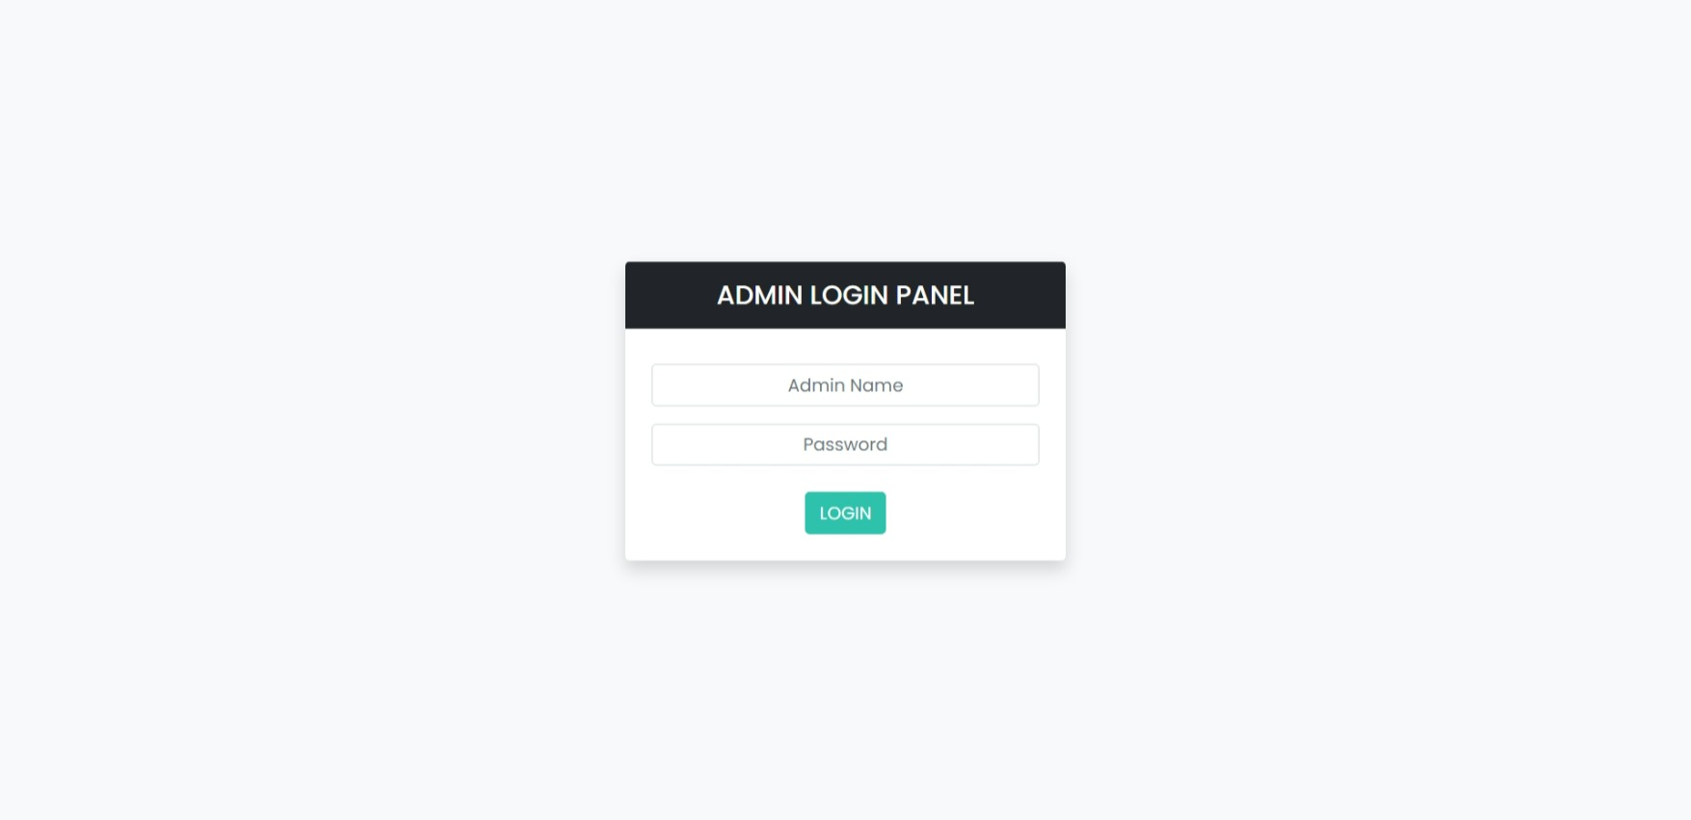

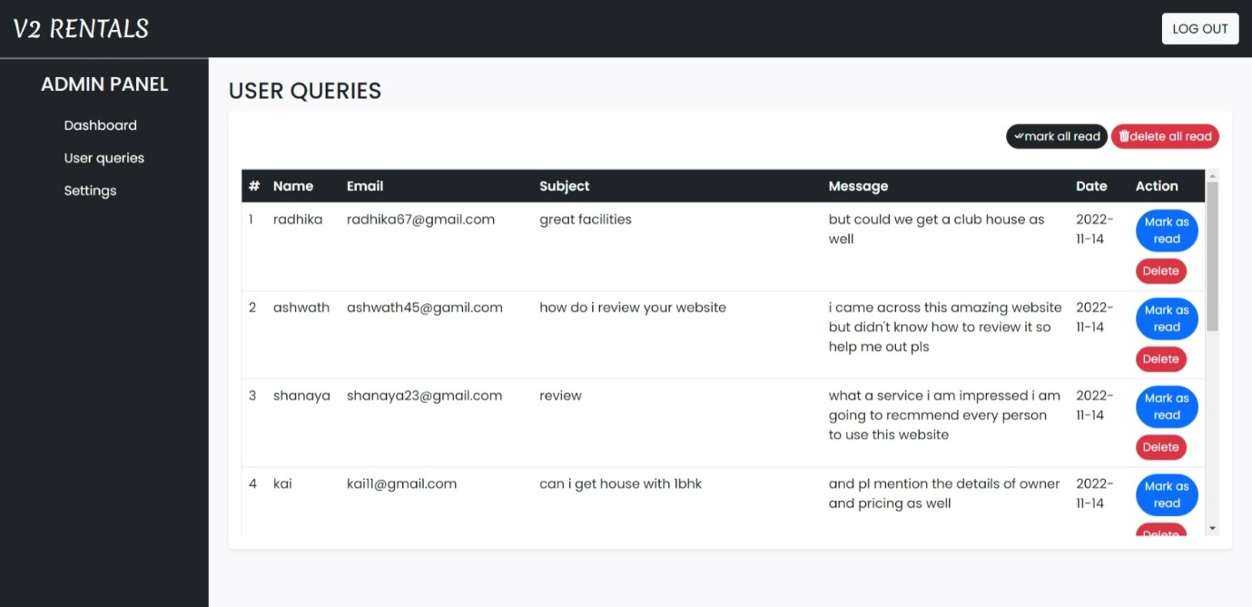

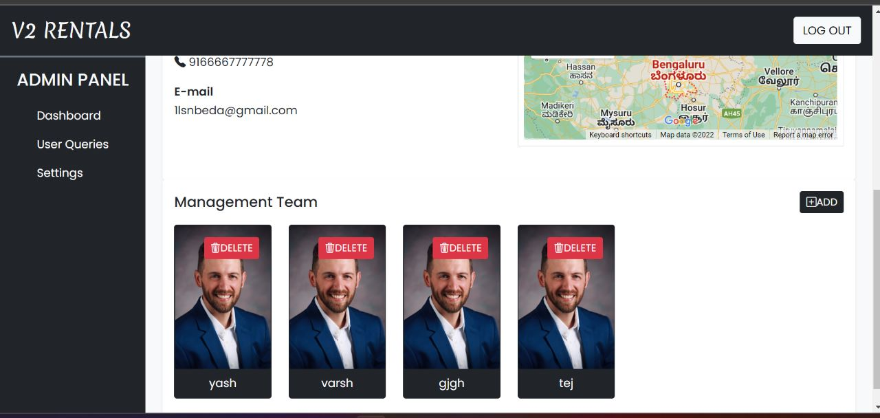

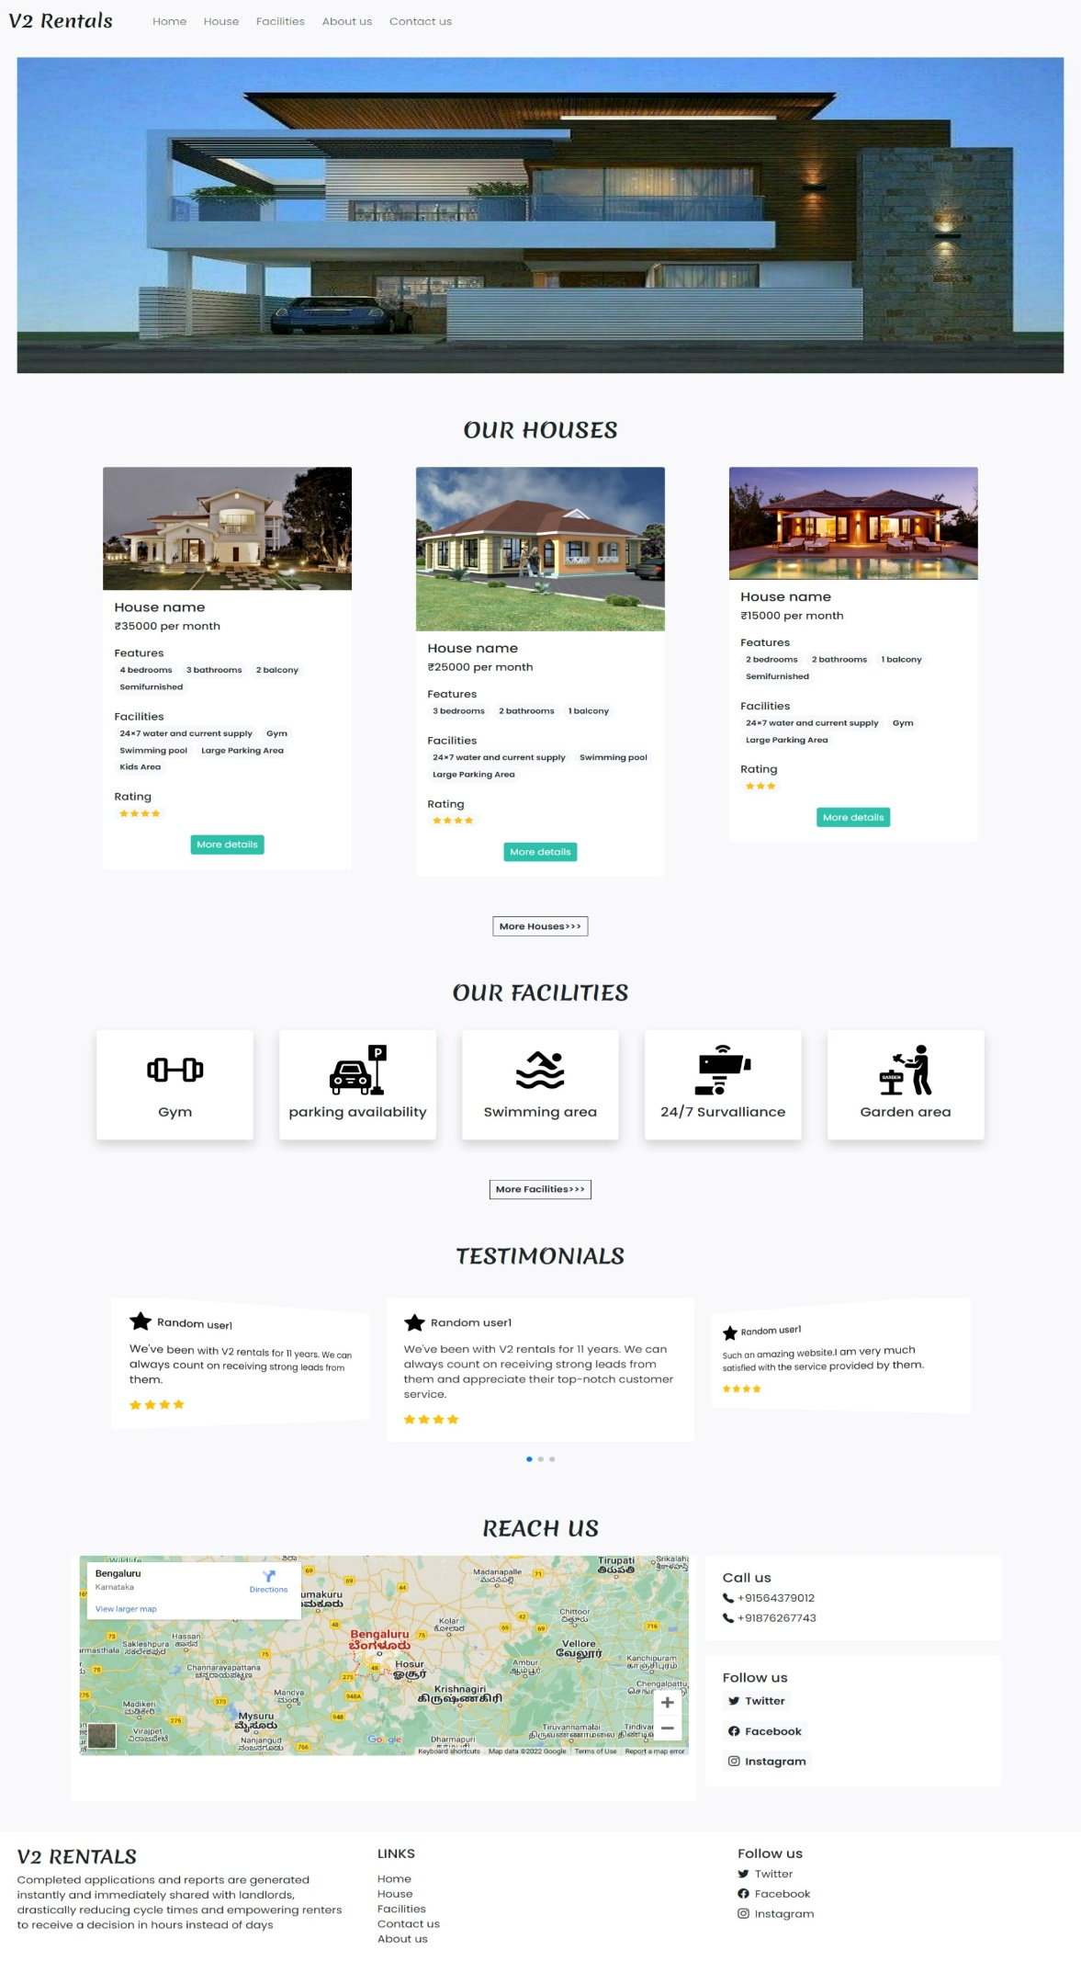

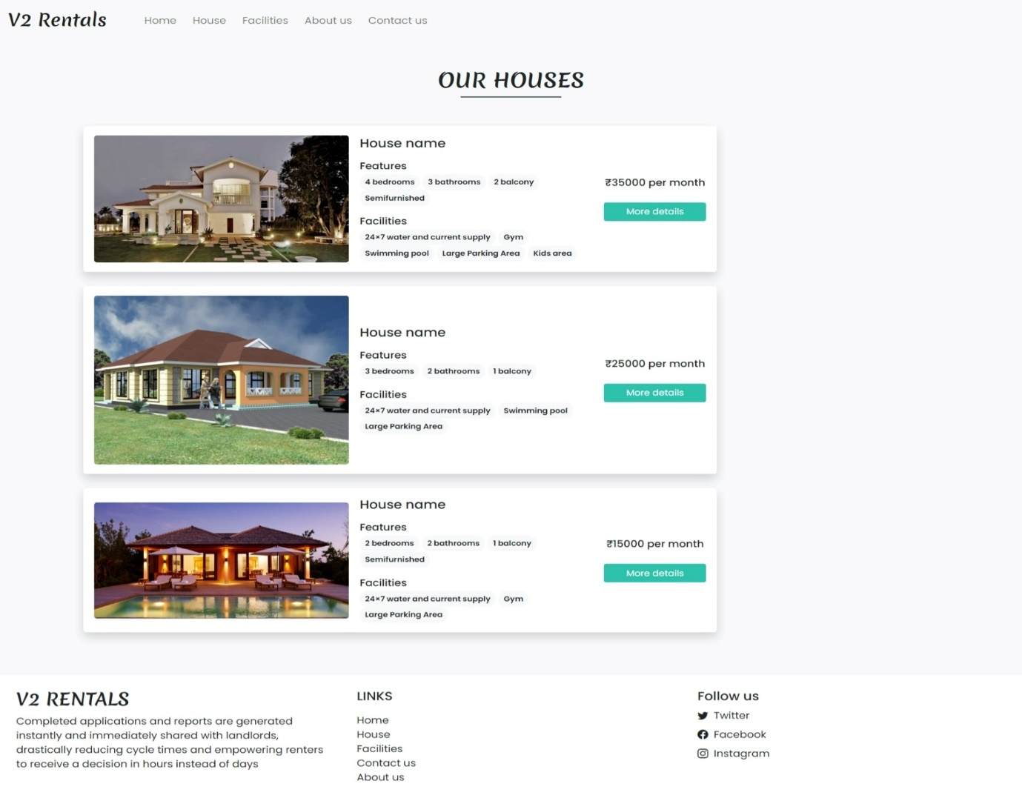

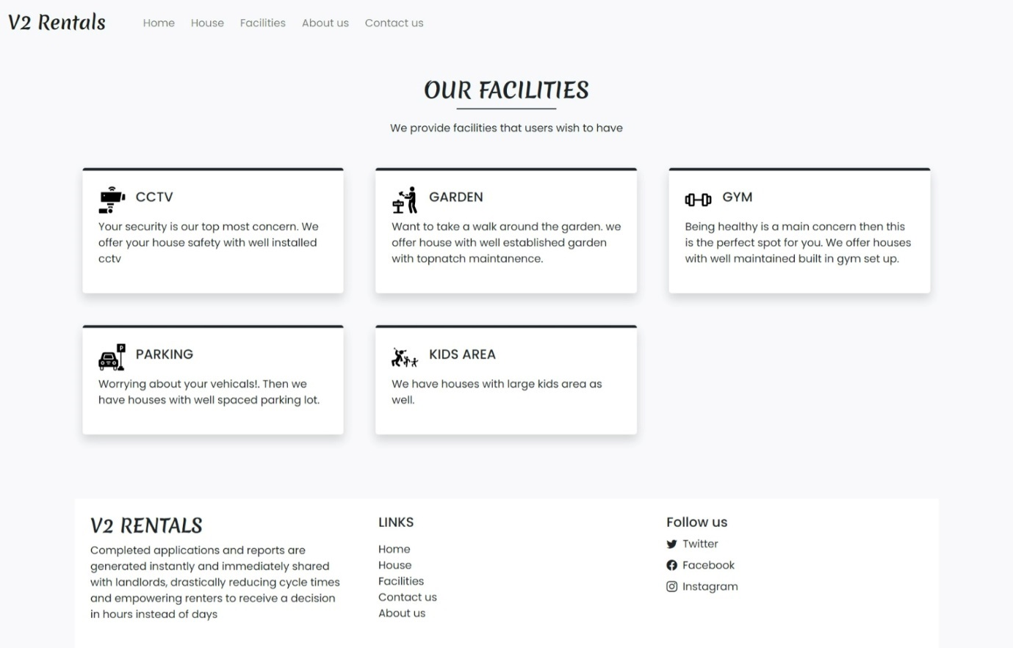

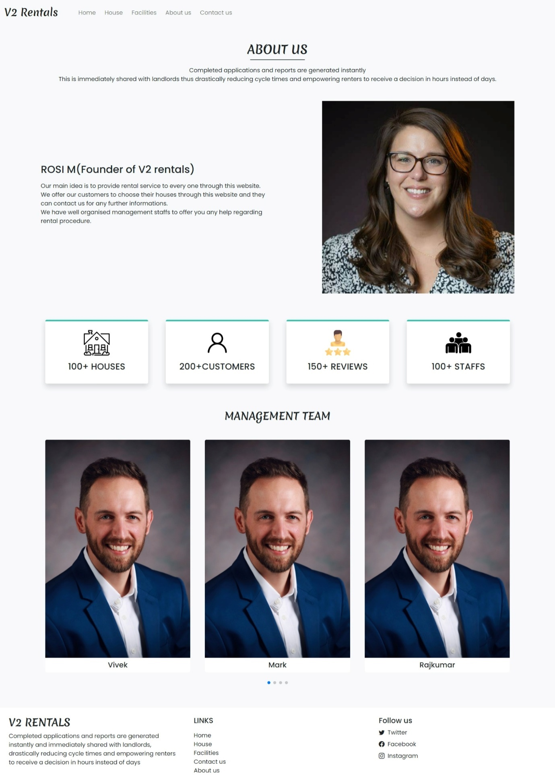

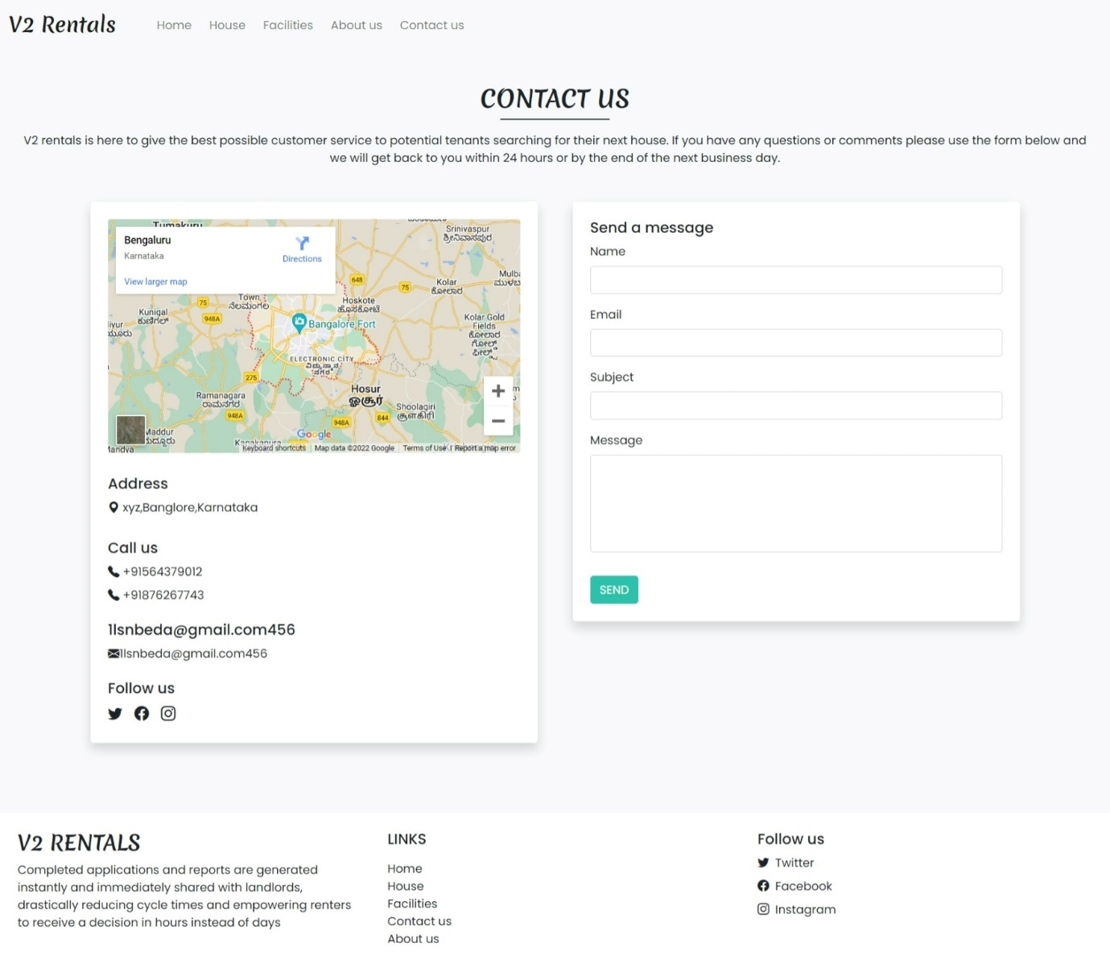

**7.REFERENCES**

**WEBSITES:**

[1] www.w3schools.com.

[2] https://www.codecademy.com/learn/learn-php.

[3] www.tutorialspoint.com.